**Task 1. What types of tourism I am talking about?**

1. Visiting the Great Barrier Reef.
2. Going to Africa to give food to the children.
3. Flying to China to learn Chinese.
4. Visiting Australia to surf the big waves.
5. Travelling to Paris, then leaving for Amsterdam, then visiting London and Cardiff.
6. Going to Israel to get some new medicine.
7. Spending summer at the Black Sea.
8. Walking along the Great Canyon in America with good friends and a big rucksack with you.

**Task 2. Identify professional qualities of a travel agent.**

|  |  |
| --- | --- |
| 1. Оказать квалифицированную помощь.  2. Координировать расписание клиента.  3. Продать билеты на самолёт.  4. Иметь хорошие навыки собеседования, телефонного разговора, работы с компьютером.  5. Сбалансировать желания клиента с реальным бюджетом.  6. Освоить много видов информации:  география, визовый режим, типы туризма. | 1. To balance client dreams with real budget; 2. To coordinate the customers’ schedule; 3. To have good interview, telephone, computer skills; 4. To sell airline tickets; 5. To master many kinds of information: geography, visa regulations, types of tourism; 6. To give experienced help. |
|
|
|

**Task 3. Match the statements in the right order.**

**Booking a Ticket.**

**Mike:**Hello, I need to schedule my trip to Paris for next week?

**Mike:**I have to reach Paris by the 24th.

**Henrita:**Is this a round trip? Will you need a return ticket, too?

**Mike:**Yes. Check that for 31st in the evening.

**Henrita:**When would you like to travel?

**Mike:**Okay, fine. I think that can work for me.

**Henrita:**Would you like to book the tickets then?

**Henrita:**It’ll be $2750.

**Mike:**Do you accept cards?

**Mike:**What’s the cost?

**Henrita:**Yes, we do.

**Henrita:**Yes, there’s a nonstop flight to Paris from Kennedy airport on 24th at 6AM. On 31st you may board flight 309 which is also nonstop at 4:30PM.

**Task 3. Match the statements in the right order.**

**Booking a Hotel.**

**Mike:**I’d like to book a hotel in Paris, please.

**Mike:**Well, I need a budget hotel that’s near the marketplaces.

**Henrita:**Certainly, just give me a sec...Okay, here’s one. It’s the Belladonna on Locke Avenue.

**Henrita:**Sure, we can help you find a great place.

**Mike:**What are the rates for 1 person?

**Henrita:**Certainly Sir, is there anything else I could help you with?

**Mike:**That’d all for now, thank you!

**Henrita:**It costs $150 per night. The room is big and has one queen size bed.

**Mike:**Okay, book that for 3 nights then, from 24th to 26th of this month.

**Task 4. Make the dialogues according to the plan**

Plan:

1. Type of tourism.

2. Place of vacation.

3. Time.

4. Way of travelling.

5. Hotel.

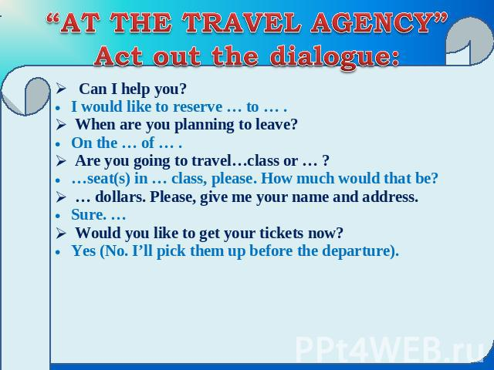

Fill in the customer enquiry form.

|  |  |
| --- | --- |
| **Customer enquiry form** | |
| Resort |  |
| Transport  From… - To…  Departure on … - Return on…  Departure time… - Arrival time… |  |
| Name, Surname |  |
| Contact phone number |  |
| Hotel |  |

***Fill in the blanks using either an infinitive or a conjugated verb as required.***

to need — to call — to make — to help — to go

Have you ever made plans for a vacation? There are many things to do ahead of time. For example, it’s important (1) __ hotel reservations. It is also essential (2) __ the airline to make sure your flights are arranged. You also (3) __ to take appropriate clothing for the climate of your destination. Sometimes, it is a good idea (4) __ to a travel agent. They can (5) __ you solve any problems related to your trip.