

**«Детское конструкторское бюро»**

Разновозрастная дошкольная группа

МОУ Талицкой средней школы Буйского муниципального района

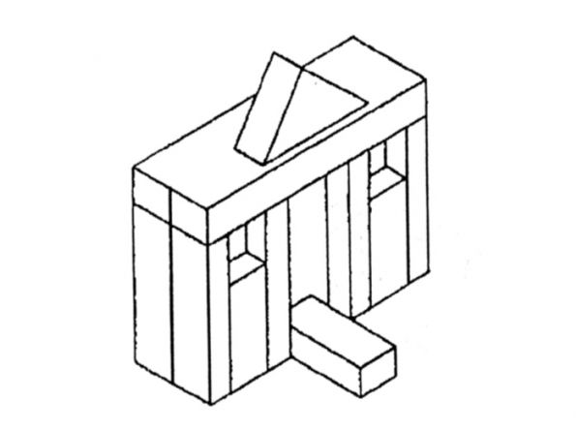

[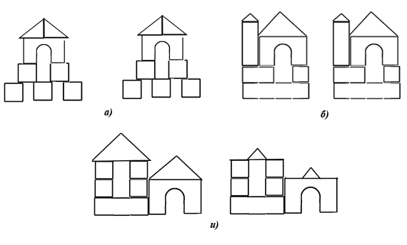](http://go.mail.ru/redir?q=%D0%A1%D1%85%D0%B5%D0%BC%D1%8B,%20%D0%BE%D0%B1%D1%80%D0%B0%D0%B7%D1%86%D1%8B,%20%D0%BA%D0%B0%D1%80%D1%82%D0%B8%D0%BD%D0%BA%D0%B8%20%D0%BF%D0%BE%20%D0%BA%D0%BE%D0%BD%D1%81%D1%82%D1%80%D1%83%D0%B8%D1%80%D0%BE%D0%B2%D0%B0%D0%BD%D0%B8%D1%8E%20%D0%B4%D0%BB%D1%8F%20%D0%B4%D0%B5%D1%82%D0%B5%D0%B9%20%D1%81%D1%82%D0%B0%D1%80%D1%88%D0%B5%D0%B3%D0%BE%20%D0%B4%D0%BE%D1%88%D0%BA%D0%BE%D0%BB%D1%8C%D0%BD%D0%BE%D0%B3%D0%BE%20%D0%B2%D0%BE%D0%B7%D1%80%D0%B0%D1%81%D1%82%D0%B0&via_page=1&type=sr&redir=eJzLKCkpsNLXT8lP0jMsTi0oSc1NSi3SKyrVL8tMLY9PLCrJTM5J1SvIKLDPTLE1MjCwMDA0NzJkuLDwYuuFrRf2XOzWUbiw78LGiw0XNlzYfrENzN91YcPFhotNF3Zc2Atk71C4sP_CPpDovgt7LzZebALKNV_YAdSx78ImoK69QHafwoUtF3Zf7AdRW4E6t17YqQBSCjaoA8jdDDJhy4V9QA7InN0Xe4D69kGENwEZ20EOgOhgMDQxt7AwNTUzMWCIL2YSf2vy_cm_l7kck0SfvgQAtQmIKA)

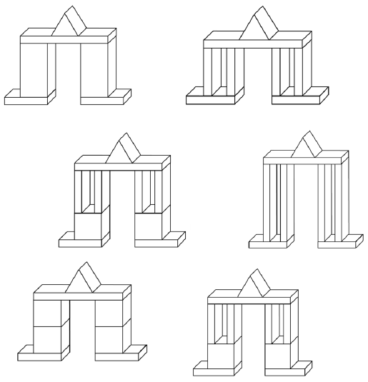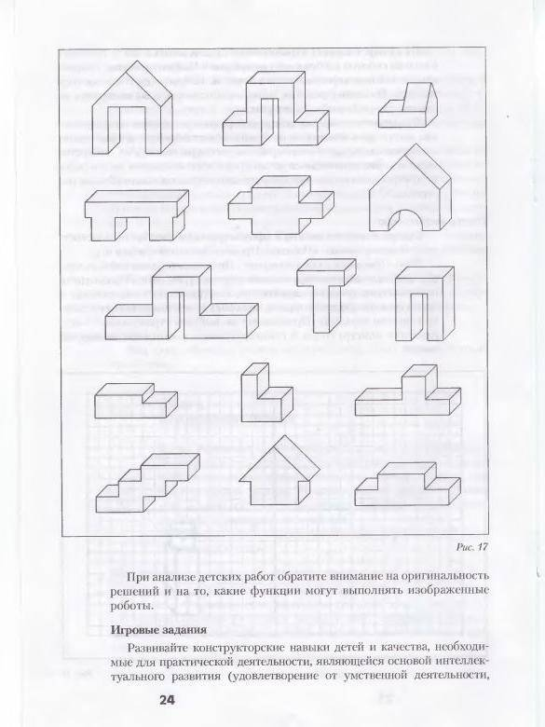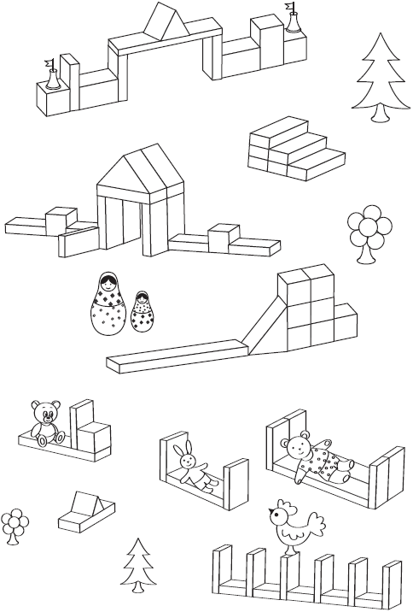

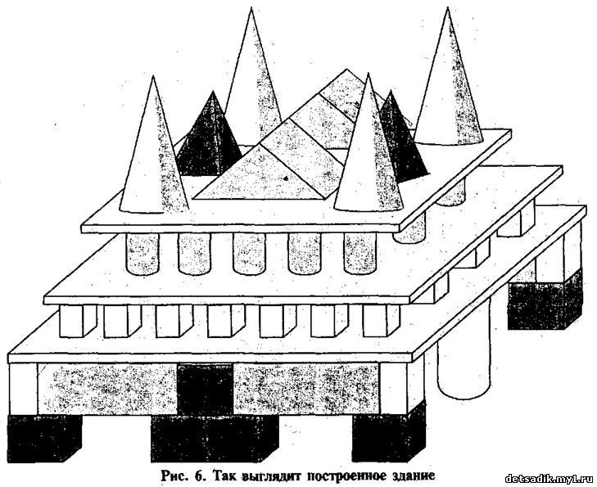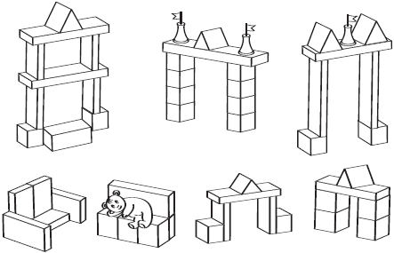

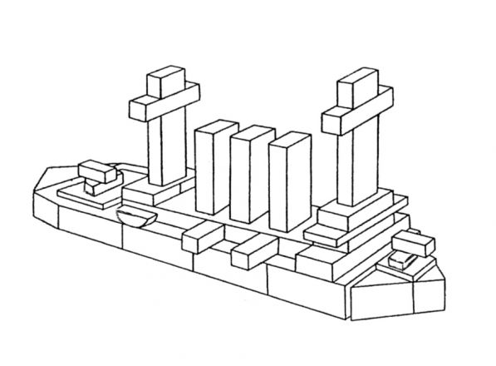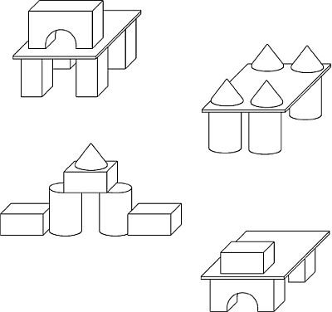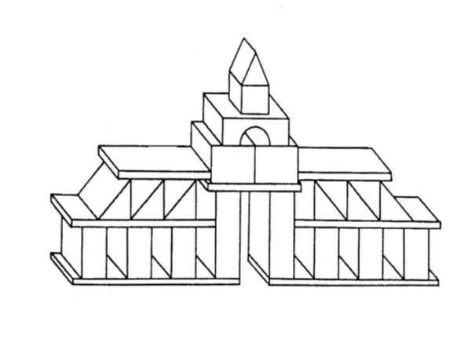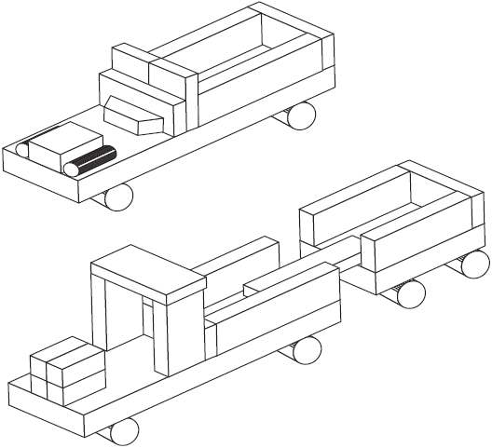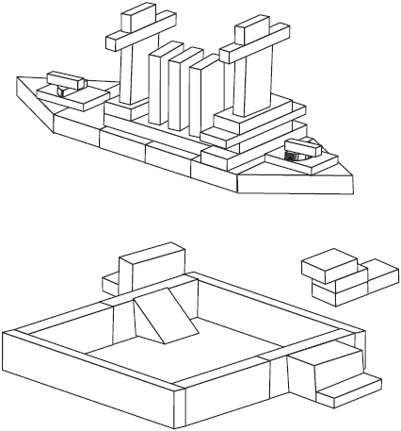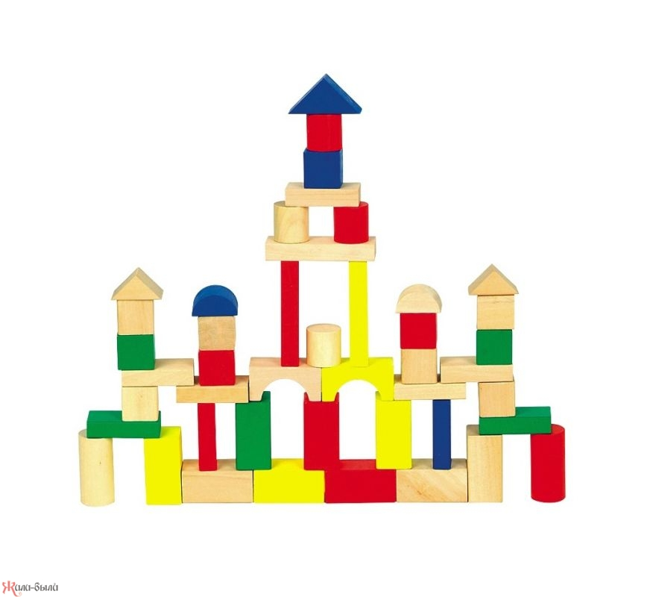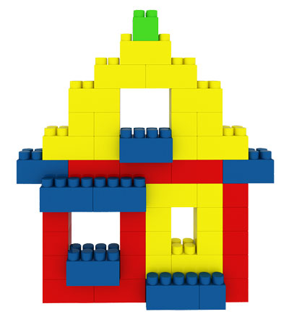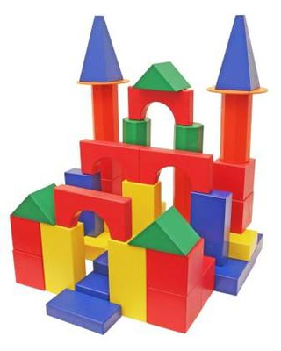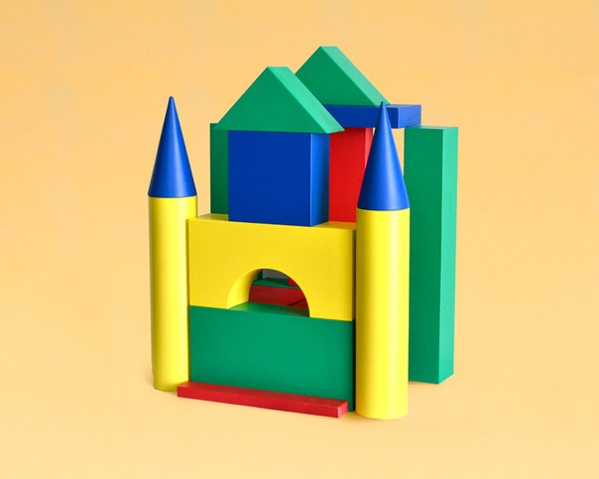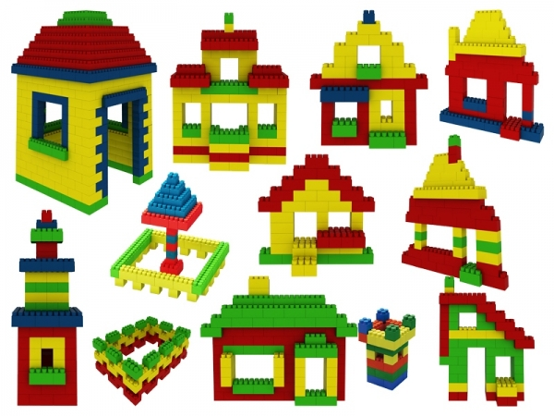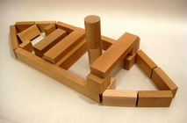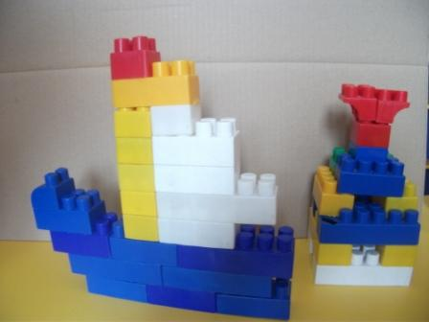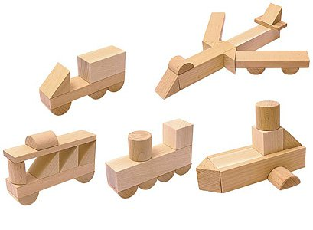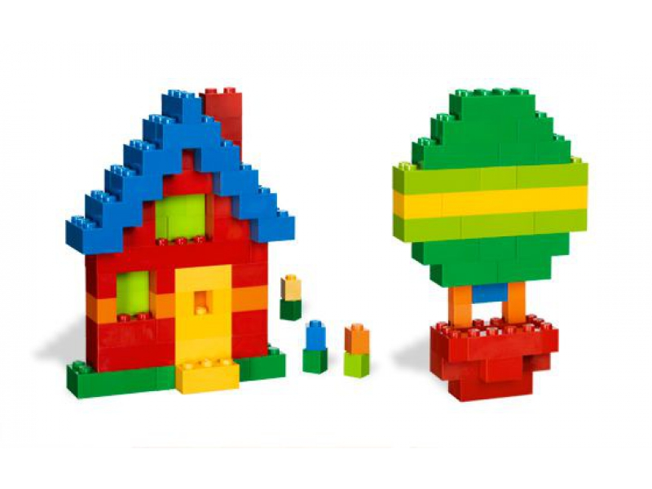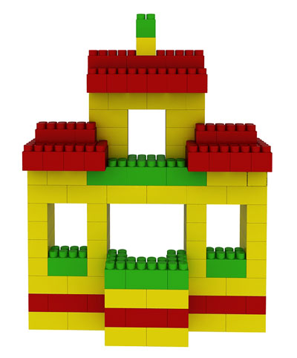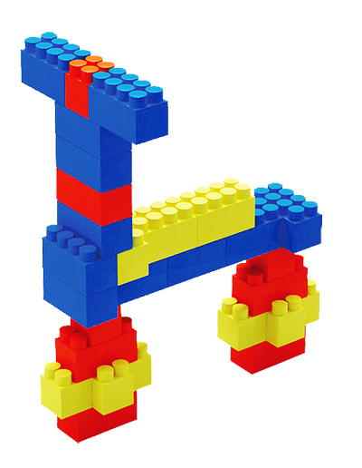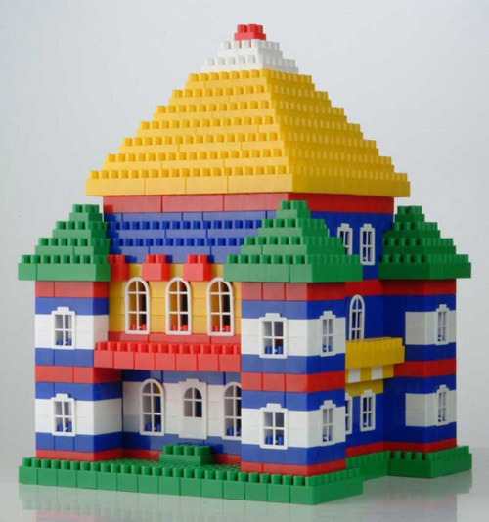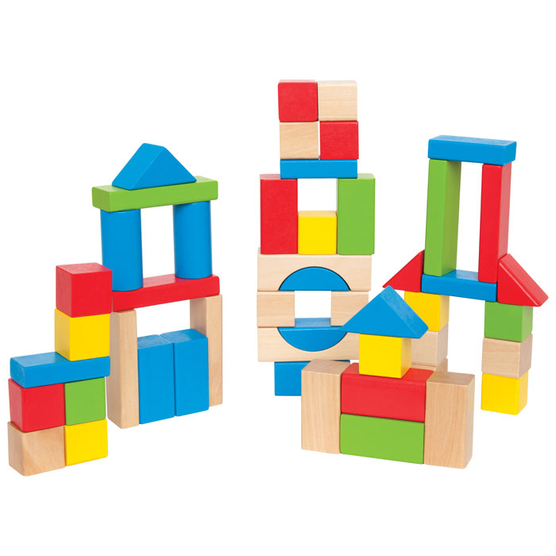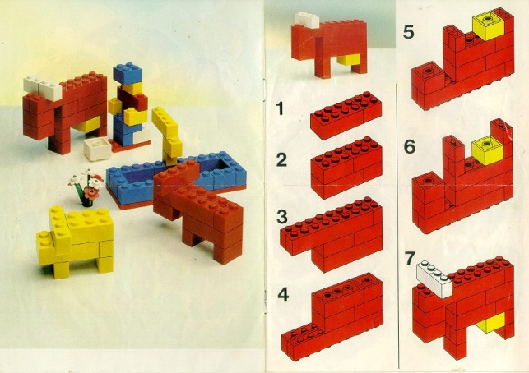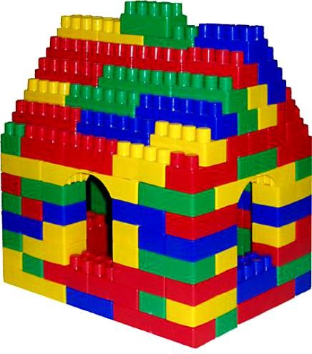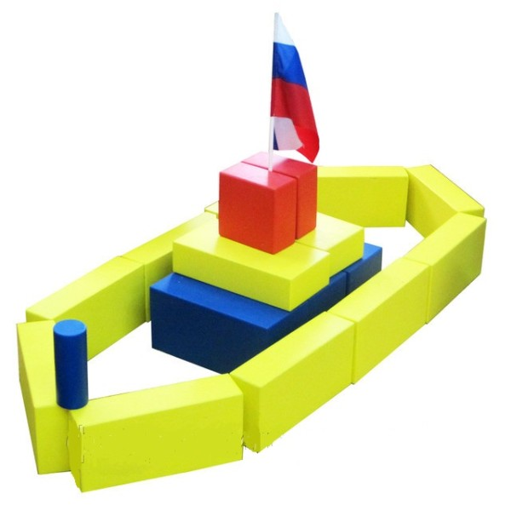

[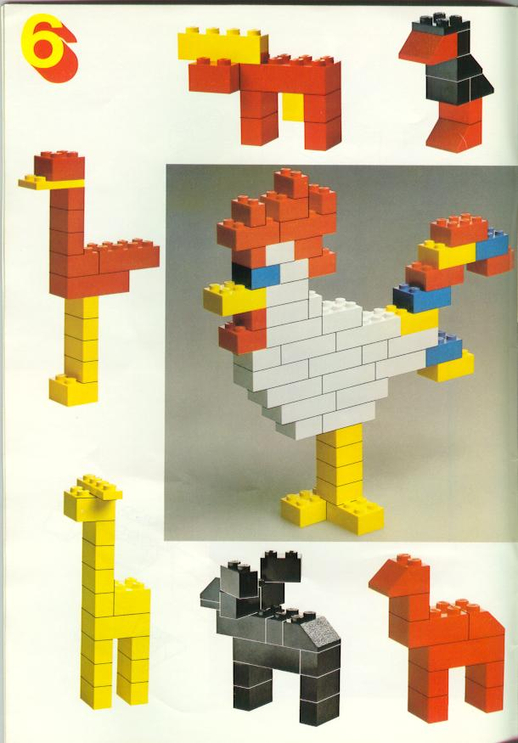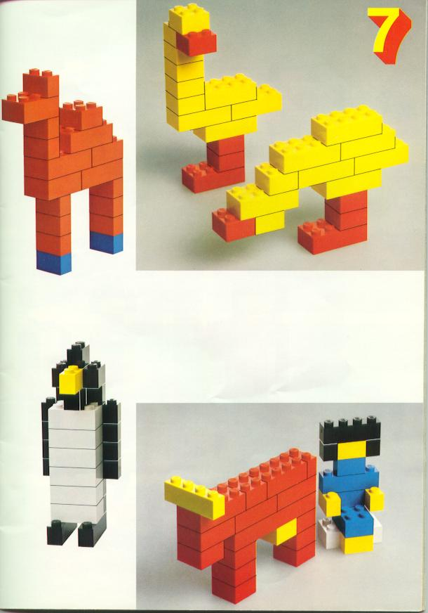](http://go.mail.ru/redir?q=%D0%A1%D1%85%D0%B5%D0%BC%D1%8B,%20%D0%BE%D0%B1%D1%80%D0%B0%D0%B7%D1%86%D1%8B,%20%D0%BA%D0%B0%D1%80%D1%82%D0%B8%D0%BD%D0%BA%D0%B8%20%D0%BF%D0%BE%20%D0%BA%D0%BE%D0%BD%D1%81%D1%82%D1%80%D1%83%D0%B8%D1%80%D0%BE%D0%B2%D0%B0%D0%BD%D0%B8%D1%8E%20%D0%B4%D0%BB%D1%8F%20%D0%B4%D0%B5%D1%82%D0%B5%D0%B9%20%D0%B4%D0%BE%D1%88%D0%BA%D0%BE%D0%BB%D1%8C%D0%BD%D0%BE%D0%B3%D0%BE%20%D0%B2%D0%BE%D0%B7%D1%80%D0%B0%D1%81%D1%82%D0%B0&via_page=1&type=sr&redir=eJwdjTFOw0AQRX0JqH0AEoNCHIsud6C3At5gy9ibeNepQyIQEggKTkBDh2QSTAzBS0f95wRchdlU8-bP_39irSfqxPOSfCzLQqbdovQyqWWUnMdCpVKEE6nkWSLCS3EhO6nMlS7KpJCzUc7iLIyEZlsWqlFUdnq-HwS9bqwzB890jRrfdHfgwuCN5qiwoZvd_oWK5rRAg5a5cfEDY1WDlq5owbclGk4YrDjVMj-4eMeWHu2oOVnj06Kh211sS_dsM1jbnhXDxv6zXaico-NBEPT7hwPfST5e10_jvZfh6d_-9Fct_wGozYtc)[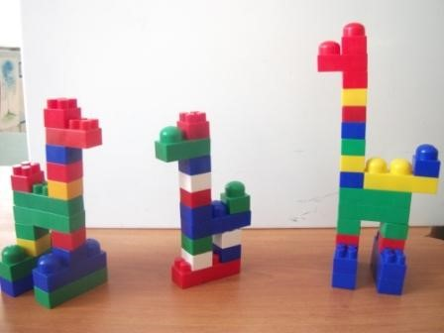](http://go.mail.ru/redir?q=%D0%A1%D1%85%D0%B5%D0%BC%D1%8B,%20%D0%BE%D0%B1%D1%80%D0%B0%D0%B7%D1%86%D1%8B,%20%D0%BA%D0%B0%D1%80%D1%82%D0%B8%D0%BD%D0%BA%D0%B8%20%D0%BF%D0%BE%20%D0%BA%D0%BE%D0%BD%D1%81%D1%82%D1%80%D1%83%D0%B8%D1%80%D0%BE%D0%B2%D0%B0%D0%BD%D0%B8%D1%8E%20%D0%B4%D0%BB%D1%8F%20%D0%B4%D0%B5%D1%82%D0%B5%D0%B9%20%D0%B4%D0%BE%D1%88%D0%BA%D0%BE%D0%BB%D1%8C%D0%BD%D0%BE%D0%B3%D0%BE%20%D0%B2%D0%BE%D0%B7%D1%80%D0%B0%D1%81%D1%82%D0%B0&via_page=1&type=sr&redir=eJwdjV1qwlAQhbOMPmYBjTG0weAa-hTwtRJp0KDmhhjFgA_R0lJQLC7BHcSfYNTmdgtnVtFdFOc6L_PNmTlnekkSNU1zGhpczqjT66SOF_tpTSmR5QXm0E_Em9EXUTDoe-aTZRsDvytYCEdJPA5iMfHCwNewpQ8U-KHlow6JHWXIcaLP-3xBThktUKJiLnX8QipVoqI5LXj3jpIdEnt2VcxrHUdc6Vu1gp0Fzgolfd1tV1rxmcRB5ewZTuqfykKuWc8Nx7HteqOubbLZq_v_gvYsfWj9ueIGp-CCzw)[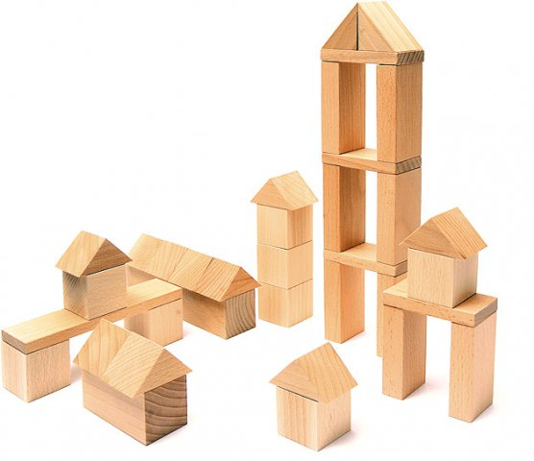](http://go.mail.ru/redir?q=%D0%A1%D1%85%D0%B5%D0%BC%D1%8B,%20%D0%BE%D0%B1%D1%80%D0%B0%D0%B7%D1%86%D1%8B,%20%D0%BA%D0%B0%D1%80%D1%82%D0%B8%D0%BD%D0%BA%D0%B8%20%D0%BF%D0%BE%20%D0%BA%D0%BE%D0%BD%D1%81%D1%82%D1%80%D1%83%D0%B8%D1%80%D0%BE%D0%B2%D0%B0%D0%BD%D0%B8%D1%8E%20%D0%B4%D0%BB%D1%8F%20%D0%B4%D0%B5%D1%82%D0%B5%D0%B9%20%D0%B4%D0%BE%D1%88%D0%BA%D0%BE%D0%BB%D1%8C%D0%BD%D0%BE%D0%B3%D0%BE%20%D0%B2%D0%BE%D0%B7%D1%80%D0%B0%D1%81%D1%82%D0%B0&via_page=1&type=sr&redir=eJwdjT1Ow0AQRi1OQWnRgrwxYomTkyC6JFphS7EVbdZxmwQRIYGgpaWixAQsGxwvV_im5wRwCWZTzZuf901szGwoRFEUwTRZqCQzSmfKBDoX-VzpuTBJqlI1iUdZMhE6H2suYTiITqUUs9GVkkFs0qmHZ7pBhR3dnfiweKMlStS02fdfKGlJazTomBsf37BuatHRita8u0bDhsWWrY75wccHWnp0pWKzwqdDS7d7raV7PrN4dzlbhtr9c1kovfCsH0VS9vrn3nF9oH_bi8OXv6fXn6Px5T8D3IM7)